Fundraising Guidance: Gift Aid
HMRC has published gift aid declarations for one-off donations, multiple donations and sponsored events. Please see the templates below:
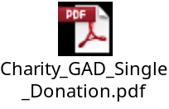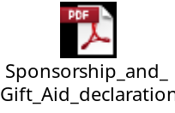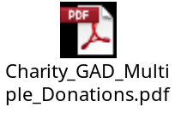
Charities holding stocks of printed materials using the previous model declarations may continue to use these until 5 April 2016, after which the new Declarations must be used.
The new Declarations have been shortened (removing unnecessary references to VAT and Council Tax) and contain clearer calls to action which demonstrates the value of making a Gift Aid claim.
Due to concerns about the tax gap and the need for donors to be fully aware of the requirement to have paid sufficient tax to cover their Gift Aid claim, HMRC has insisted on new wording making clear this responsibility to pay any difference.
HMRC recommends that all charities use the wording of the HMRC approved model declarations but it is just a model and you can adapt it for your own uses, including to incorporate your own branding or additional messages as you see fit.
What declarations must include
There is no set design for a declaration form or a verbal declaration, but it must include:
• the name of your charity
• the donor’s name
• the donor’s home address
• whether the declaration covers past, present or future donations or just a single donation
• a statement that the donor wants Gift Aid to apply (this could be a tick box on a written or online declaration)
• an explanation that the donor needs to pay the same amount or more of UK income tax and/or Capital Gains Tax as all charities will claim on the donor’s gifts in a tax year and that the donor is responsible for paying any difference

If you are organising a sponsored event your sponsorship forms can include a Gift Aid declaration. The forms must also include the:
• amount of donations collected
• date that pledged donations were collected
• date when the sums collected were handed over to you

