
MMR toolkit

Overview
The MMR vaccine consistently has one of the lowest take up rates of all childhood immunisations. The London take up consistently lags behind the national average.
There is much disparity across London as well, with uptake MMR2 at 5 years varying from 58% to 87% uptake across the 32 boroughs. It should be noted that 95% vaccine coverage is needed for herd immunity to work

Key messages
The messages below will form the backbone of all comms, briefings etc
- If your child has missed any of their MMR vaccinations, it’s never too late to catch up – check your child’s Red Book, if they have one, or contact your GP to book an appointment
- The MMR vaccine is a safe and effective combined vaccine. It protects against three serious illnesses (measles, mumps and rubella) – these are highly infectious conditions can easily spread between unvaccinated people.
- The MMR vaccine is given in two doses – the first at one year old, the second at three years and four months

MMR vaccine – what is it?
The MMR vaccine is a safe and effective combined vaccine.
It protects against three serious illnesses:
- measles
- mumps
- rubella (german measles)
These highly infectious conditions can easily spread between unvaccinated people.
Getting vaccinated is important, as these conditions can also lead to serious problems including meningitis, hearing loss and problems during pregnancy.
Two doses of the MMR vaccine provide the best protection against measles, mumps and rubella.
The MMR vaccine is given to babies and young children as part of the NHS vaccination schedule.
The MMR vaccine is not linked to autism
There's no evidence of any link between the MMR vaccine and autism. There are many studies that have investigated this.
The Oxford University Vaccine Knowledge Project website has a list of MMR studies and their findings

MMR vaccine schedule
Child's age | Vaccine
1 year | MMR (1st dose)
3 years and 4 months | MMR (2nd dose)

Resources

Newsletter/bulletin/website copy
Make sure your child is up to date on their routine vaccinations
Many children have missed vital routine vaccinations over the past couple of years, putting them at risk of preventable diseases. The good news is that it’s not too late to protect your child.
Your child is eligible for their MMR jabs at 1 year, and 3 years and 4 months. Check your child’s red book, if they have one, or contact your GP, to check your child’s vaccine status. If your child has missed one or both of their vaccinations, it’s not too late – make an appointment with your GP as soon as you can.
All vaccines used in the UK have been approved by the UK’s independent medicines and vaccines agency. Find out more at www.nhs.uk/MMR

Social media/WhatsApp
Twitter
Suggested image | Text
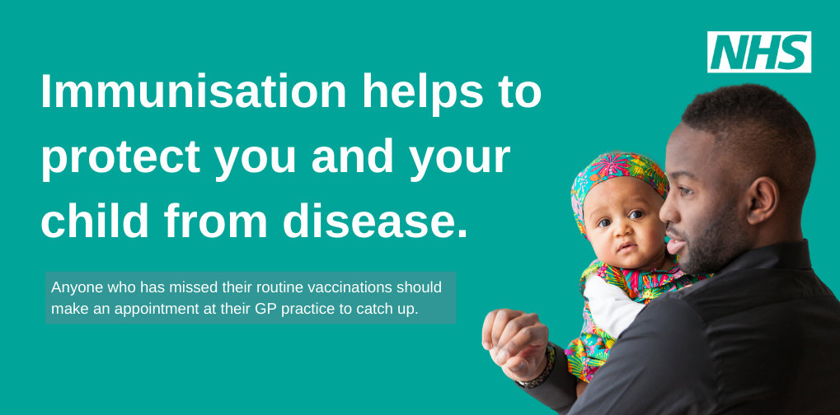 | Is your child aged 1-5? Make sure to take them for both doses of their MMR vaccine. Missed an appointment? It’s not too late – contact your GP to rebook. For more information visit nhs.uk/MMR
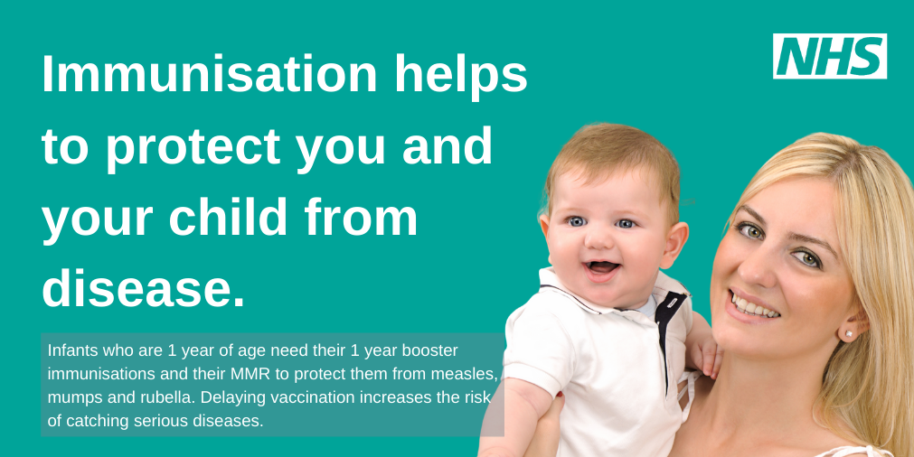 | If your child is due to have had two doses of MMR but has not yet received them, it’s not too late, contact your GP practice to get them vaccinated as soon as possible.  nhs.uk/MMR

Facebook/Instagram
Suggested image | Text
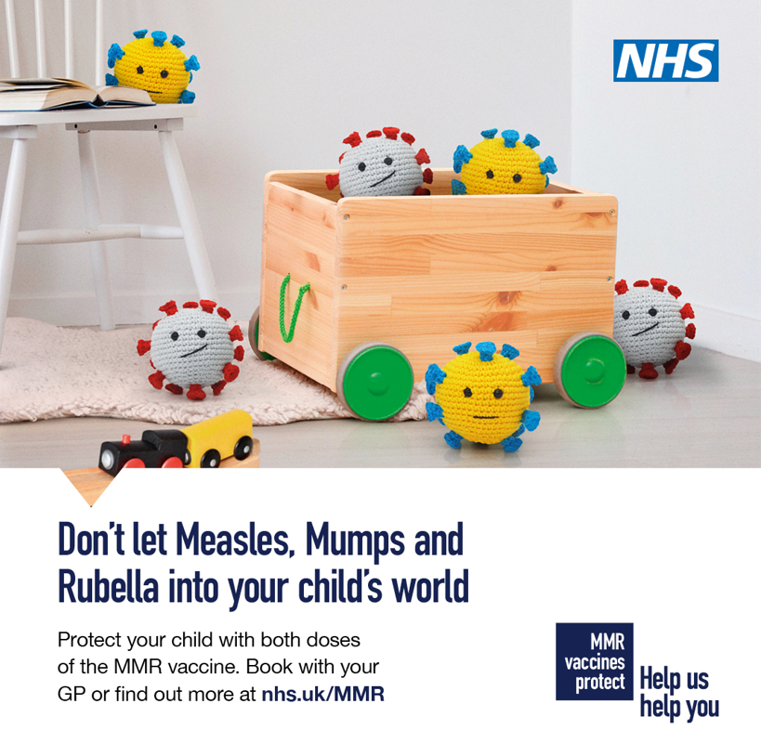  (static) | The MMR vaccine is the safest and most effective way to protect your child and community from measles, mumps and rubella, which can cause serious illness.  If your child is due to have had two doses of MMR but has not yet received them, or has missed them for any reason, it’s not too late – contact your GP practice to get them vaccinated as soon as possible.  To find out more visit nhs.uk/MMR
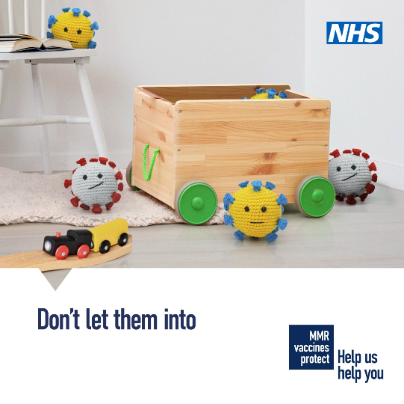  (video) | Measles, mumps and rubella can cause serious complications, which is why it’s important to get your child vaccinated.  The MMR vaccine is safe and offers the best protection for your child and community.  If you can’t remember if your child has had their MMR vaccines, check their personal child health record (red book) and speak to your GP practice to book their first or second dose.  Visit nhs.uk/MMR for more information.

WhatsApp message
- If your child has missed their MMR vaccines over the past couple of years, it’s not too late – you can still make an appointment with a GP to get them caught up. Check your child’s Red Book (their personal health record) to find out their vaccination status or contact your GP surgery.

Other resources

Campaign Resource Centre
There is additional collateral and the national strategy on the campaign resource centre
https://campaignresources.phe.gov.uk/resources/campaigns/135-childhood-vaccination-2022/resources

Health Publications
There is a range of collateral that can be ordered for free or downloaded from the Health Publications website – some examples shown below
https://www.healthpublications.gov.uk/ArticleOverview.html?sp=Sall&sp=Sft-59%2C220&sp=Sreset
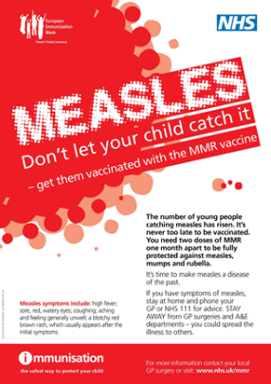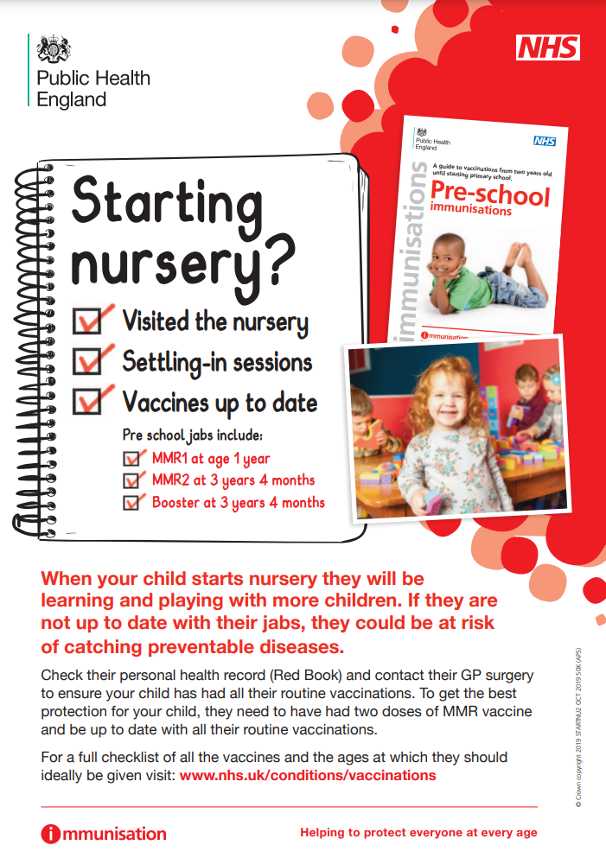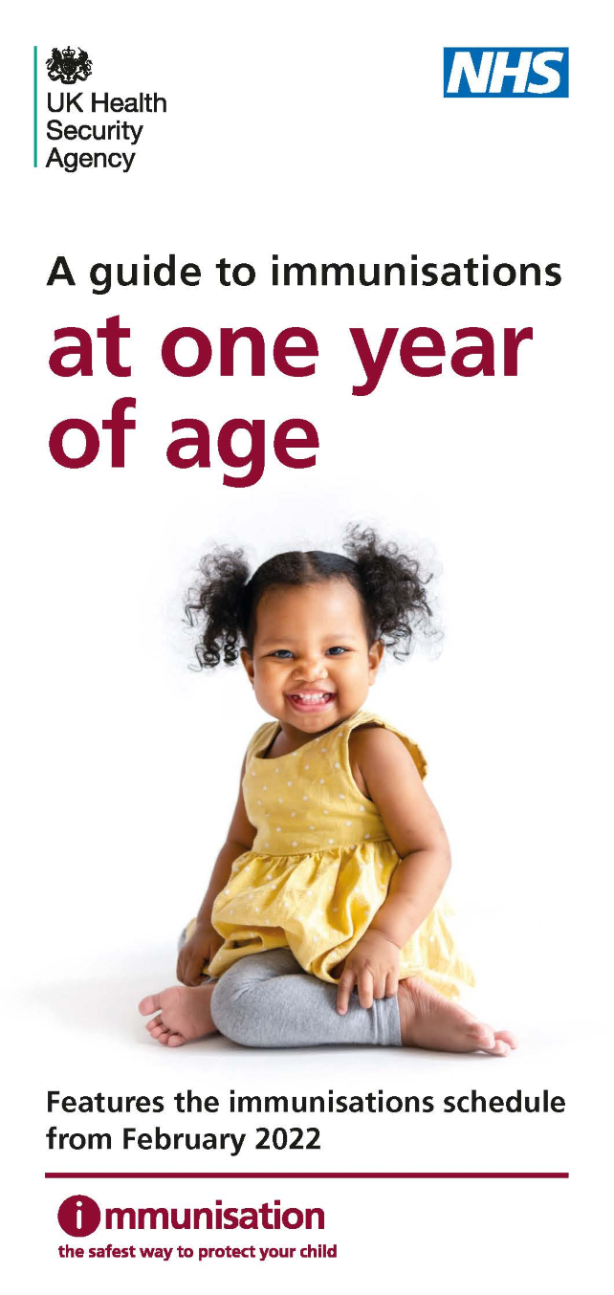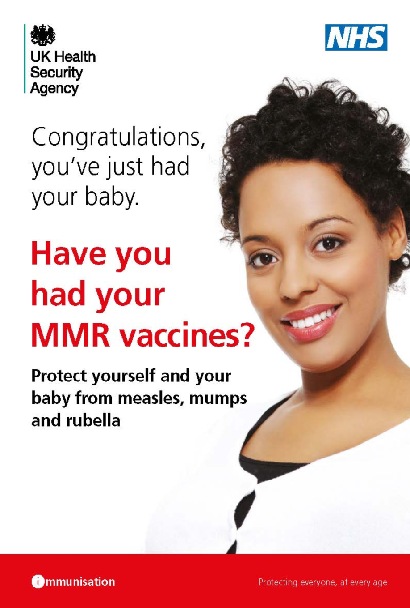
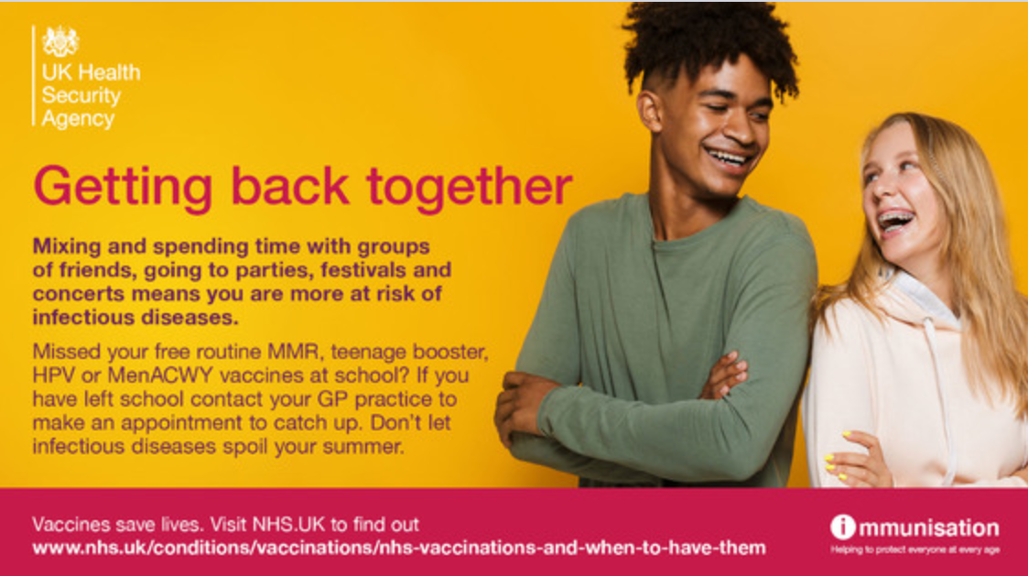

Q&A
What is the MMR vaccine?
The vaccine, protecting against measles, mumps and rubella has been around since 1988, almost 35 years. It is part of the routine childhood immunisations that are given to your child to protect them from a range of diseases. The MMR vaccine is usually given when your child is a year old, with a booster given when they are three years and four months old.
We know that lots of children might have missed their vaccine appointments over the past couple of years owing to lockdown. The good news is that it’s never too late to get both doses of the MMR jabs to give you child lifelong protection against measles, mumps and rubella.
You might have heard stories linking the vaccine to autism. There's no evidence of any link between the MMR vaccine and autism. There are many studies that have investigated this. The vaccine is safe, has been used for many years and gives great protection against some potentially serious diseases.
I don’t know if my child has had their jabs – how can I check?
You can check your child’s personal child health record, you might know it as the “red book”. Most people are given it when their baby is born. If you don’t know where yours is don’t worry, make contact with your GP team and ask to know which vaccinations your child has received in the practice.
My child has missed their jabs – is it too late?
It’s never too late to catch up on these important vaccinations – you can still ask your GP surgery for the MMR vaccine if your child has missed either of these two doses.

Why do we vaccinate?
After clean water, vaccination is the most effective public health intervention. Vaccines protect you and your child from many serious and potentially deadly diseases. They undergo rigorous safety testing before being introduced and they’re also constantly monitored for side effects after being introduced. All medicines and vaccines in use in the UK have been approved by the UK’s independent regulator.
Thanks to vaccines, some diseases that used to kill or disable millions of people are seen very rarely. However, if people stop having vaccines, it's possible for infectious diseases to quickly spread again.
Do I have to vaccinate my child? How serious are measles, mumps and rubella?
As many people in this country have been vaccinated with the MMR it can be easy to forget what it was like to have these illnesses or to see children with them. They are all highly infectious and can spread easily between unvaccinated people.
Measles usually starts with cold-like symptoms, followed by a rash a few days later. Some people may also get small spots in their mouth. Measles can lead to serious problems if it spreads to other parts of the body, such as the lungs or brain. If you catch measles when you are pregnant, it can harm your baby.
Mumps is most recognisable by the painful swellings in the side of the face under the ears. It usually passes without causing serious damage to a person's health. Serious complications are rare, but mumps can lead to viral meningitis if the virus moves into the outer layer of the brain.
Other complications include swelling of the testicles or ovaries (if the affected person has gone through puberty).
Rubella (german measles) is a rare illness that causes a spotty rash. It usually gets better in about a week, but it can be serious if you get it when you're pregnant
The good news is that your children and any pregnant people can be protected from these illnesses and their complications safely and easily by having the MMR vaccination.
The health care professionals giving the vaccinations are expert at doing this. They know how to make your child as comfortable as possible and will help you in the consultation.
If you have any questions at all about it please talk to a trusted healthcare professional like a health visitor, school nurse, GP nurse or GP.
For more information on the MMR vaccine please visit nhs.uk/MMR

https://www.ecdc.europa.eu/en/measles/prevention-and-control/addressing-misconceptions-measles
https://www.nhs.uk/conditions/vaccinations/mmr-vaccine/

