Event Feedback Summary Report
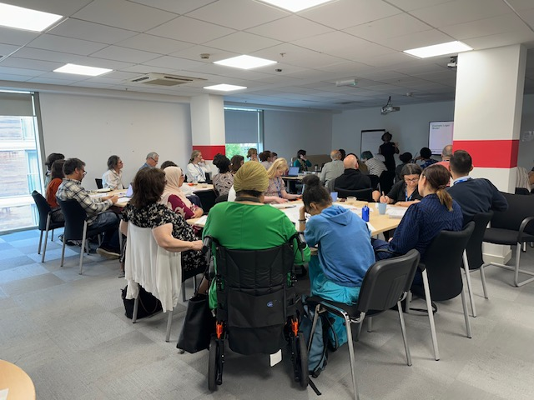

Event: Evidencing Your Impact and Partnership Working
Date: 30 July 2025
Venue: Voluntary Action Islington

Number of people registered to attend the event: 61
Apologies sent for not attending the event: 1
Number of people who attended the event: 46
Conversion rate: 75%

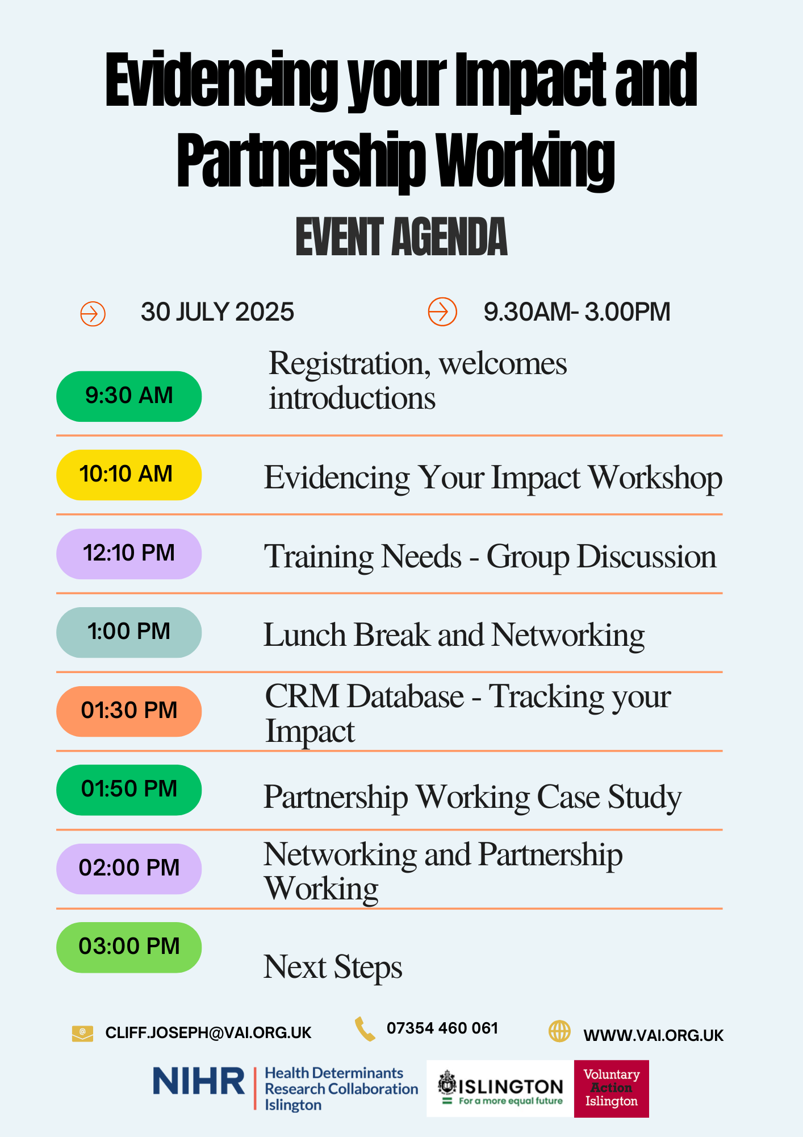
The first part of the day was delivered by Evidence Islington and focused on the theme ‘Evidencing Your Impact’. The workshop was well received, with many organisations reporting that they gained valuable insights into evaluation methods, data collection, and the importance of using evidence to demonstrate outcomes effectively.

Verbal feedback indicated that participants felt more confident in their understanding of impact measurement following the session. Several attendees expressed that the information provided had clarified key concepts that will support them in improving their current evaluation practices.

Sawsan (CEO of KMEWO for over 30 years) has worked closely with grassroots organisations in Islington. She shared that “The event and workshop were very useful. We should be thinking about offering this to staff and volunteers. Although I have had training and understand it, many of my team lack the skills and knowledge, and as a result we are often unable to collect evidence. This is a common issue across smaller organisations.”

The session addressed a critical need across the voluntary sector and highlighted the importance of continued support for organisations in building their capacity to evaluate and evidence their work.

Networking and Partnership - Impact Summary
Delivered by the Voluntary Action Islington (“VAI”) team
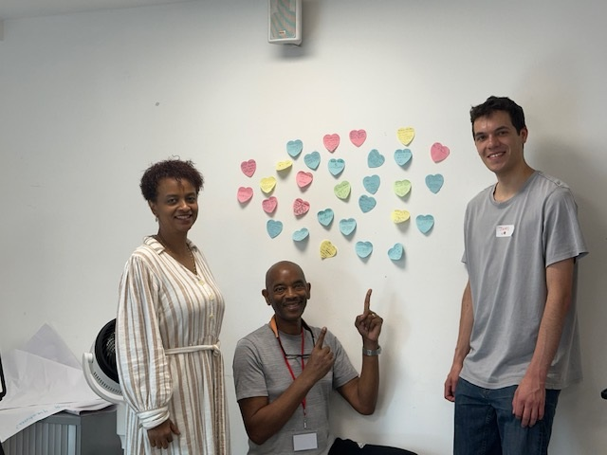
The networking and partnership section of the event was highly interactive and generated strong engagement. Attendees participated in facilitated networking, followed by a presentation from a partner organisation exploring both the challenges and benefits of partnership working. This helped frame the importance of collaboration within the sector.
Additionally, to support ongoing relationship building, a short guidance resource was provided to attendees to take away. This included practical tips on developing and sustaining effective partnerships.
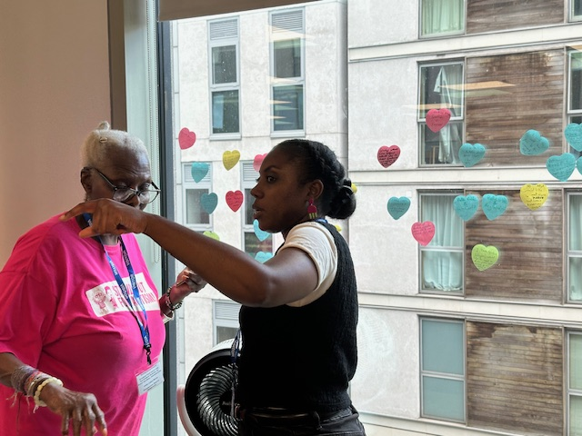
As a direct outcome of the session, 31 requests for e-introductions were submitted by attendees. On 30 July, 28 of these introductions were actioned, with three requiring further follow up due to unclear details.

Early feedback suggests the session successfully encouraged new connections and increased confidence among organisations in exploring partnership opportunities. Further tracking of these initial e-introductions will assess how well these initial connections have developed.

- Satisfaction Levels

- Suggestions for Improvement
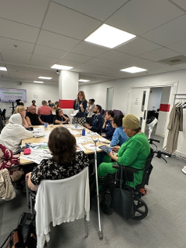
- More time for discussions
- An intro from each person about what they do right from the beginning
- Speakers need a microphone
- Nothing
- It may be helpful to allow some time to go around and tell the room what organisation we are with and what we do to know who may be best to talk to. I know I made the relevant connections on my table, but I don’t know about the rest of the room.
- Some parts felt rushed
- Would have liked to hear more on “Evidencing your Impact”
- Keep it up
- N/applicable. Very professional
- Overall, the event went well. There was good engagement in the room. The only challenge was noise levels, which made it difficult for some people to follow.
- Share Organisation Names and contact details
- To have more layout paper about the event/people speak little loudly
- Very good event - I would shorten it overall, incl. afternoon case studies
- The networking was extremely rushed and high pressure and ended up being useless because of it. In general, the discussions were also rushed and if you were in a group with a very dominant person who took up a lot of space there was no time for anyone else to have input.

3. Actions Attendees Plan to Take
- Networking and potential collaboration in the future
- Connect with attendees
- Seek more opportunities for partnership working and explore the theory of change model with projects
- Connect with others via LinkedIn and look forward to seeing the templates
- Looking into how we make better use of gathering and processing data.
- See what other support I can get through VAI
- Aim to set up groups of clients and volunteers to discuss how we can improve our services
- Revise the info
- Approaching Evidence Islington
- Further learning in research
- I've made several contacts today and will follow up with people after today
- Make sure I’ve filled in the survey. Look at CRM. Read the minutes if there are any.
- Do more partnership with other organisation doing similar work that has never collaborate before.
- To be more involved
- Progress consistent theory of change across organisation to clarify and align mission and long term intended impact
- None

4.Organisations Attendees Want to Connect With

Organisation / Group | Mentions
Mental Health and community centres | 1
YATI  ADHD ISLINGTON  LAAMIGA  BLACK HEALTH HUB | 1
ADHD Islington | 1
Shared Lives | 1
Black Culture Centre | 1
Evidence Islington and any other organisations that work with young people and families | 1
ADHD Islington and Go Africa Community Hub. | 1
Council or VAI in Islington | 1
Other local food banks. Evidence Islington is to see if they can offer practical support to help is show impact | 1
Evidence Islington | 2
MAX | 1
Voluntary Action | 1
N/A. I'll get the information from the training needs assessment | 1
I don’t know. I’ll wait to see if anyone else wants to connect. | 1
Thank you very much for organising a wonderful event 😊 | 1
Mental health | 1
funding opportunities | 1

5. Notable Comments and Recurring Themes
- The catering was very good.
- Thank you for a great and informative day
- Well delivered - thank you
- The pesto was great.
- Thank you
- Thank you, and keep it up
- Just to say thank you
- Congratulations for providing professional development
- It was fun to meet people and thanks for a good lunch.
- Nothing
- To train us, as we are Somali community, want to learn system.
- Thank you for arranging such an informative and productive event

